03/01/2013:

**DGP XML Reader issues found whilst testing:**

1. **Issue in the ReleaseList - ReleaseType for the individual tracks:**

The ReleaseType for individual tracks whether Audio or Video are currently mapped to the ReleaseType of the product.

For an Audio product album, the releasetype tags at track level should always be:

<ReleaseType>TrackRelease</ReleaseType>

For a Video products album, the releasetype tags at track level should always be:

<ReleaseType>VideoTrackRelease</ReleaseType>

Please note that this should also be the case, when we use UserDefined ReleaseType at product level, such as for example AlbumWithBooklet, BundleAlbum, etc.

Please note that the actual xmls are correct so it is really a reader mapping issue.

Please see in Annex 1 and 2 the corresponding screenshots.

1. **Issue with the pre-order in the DealList:**

When using the reader to look at an example xml of a pre-order with bonus track album, the reader displayed correctly the bonus track.

It also showed the <AllDealsCancelled>true</AllDealsCancelled> tag both for the product during the pre-order period and the bonus track after the pre-order period.

However the two tags for the pre-order (<PreOrderReleaseDate>and<PreOrderPreviewDate>) are completely invisible.

Please see corresponding screenshot in Annex 3.

1. **Issue with the various types of Titles in the <ResourceList> for Classical content:**

For Pop content, the only title used is the <ReferenceTitle>, so it doesn’t matter hugely if the Title is not qualified.

However this becomes a problem for Classical content, where we use not only the <ReferenceTitle> but also the GroupingTitle and even more importantly the DisplayTitle.

The situation is similar with Translation where again the <TranslatedTitle> should be qualified.

The reader is blind to these distinctions and simply displays 3 titles on top of each other with no indication to what they are in the <ResourceList>.

So this could be hugely confusing to the end user, so the different types of titles need to be obvious.

Please note that the <TranslatedTitle> does appear as such in the <ReleaseList> but not at Resource level so that is inconsistent in any case.

Please see corresponding screenshot in Annex 4.

1. **Issue with the distinction between Primary or Secondary resource in the ReleaseList:**

The reader doesn’t display clearly whether a resource is Primary or Secondary.

At the moment, the summary section Product Structure, just shows “Other Resources”.

The distinction should be indicated as Sequenced or Unsequenced resource.

This would mirror DSC vocabulary and would help the end user.

1. **Issue with missing toggle button Filter By Territory for all the Video products, Videomastertone and Wallpaper products:**

The Filter by Territory button is not displaying the various territories for Video products, Videomastertone and Wallpaper product.

Please see corresponding screenshots in Annex 5 and 6.

1. **Display of the Technical Details in the <ResourceList>:**

I did not see any issue as such with the way the assets technical information are displayed but it would be great if when there are several assets contained in the xml, we could see them with a line space separating them.

At the moment as they are stacked up on top of each other, it is not completely obvious when one stops and the other starts.

Please example below:

**Technical Details**  
File Name : UMG_audtrk_00016581578029_01_001_67.mp3  
Hash Sum : 94054b229592bbd48cad0c49cd105116  
Hash Algorithm : MD5  
Reference : T85696600  
Audio Codec : MP3  
Bitrate : 320  
Channels : 2  
Sampling Rate : 44100  
Bits Per Sample : 16  
Preview : false  
File Name : UMG_audclp_00016581578029_01_001_100.mp3  
Hash Sum : 9e28ad8c6c7eb1ffcfb21ddadf4c01a6  
Hash Algorithm : MD5  
Reference : T85697615  
Audio Codec : MP3  
Bitrate : 64  
Channels : 2  
Sampling Rate : 22050  
Bits Per Sample : 16  
Preview : true

It would be clearer if it could be instead:

**Technical Details**  
File Name : UMG_audtrk_00016581578029_01_001_67.mp3  
Hash Sum : 94054b229592bbd48cad0c49cd105116  
Hash Algorithm : MD5  
Reference : T85696600  
Audio Codec : MP3  
Bitrate : 320  
Channels : 2  
Sampling Rate : 44100  
Bits Per Sample : 16  
Preview : false

File Name : UMG_audclp_00016581578029_01_001_100.mp3  
Hash Sum : 9e28ad8c6c7eb1ffcfb21ddadf4c01a6  
Hash Algorithm : MD5  
Reference : T85697615  
Audio Codec : MP3  
Bitrate : 64  
Channels : 2  
Sampling Rate : 22050  
Bits Per Sample : 16  
Preview : true

Annex 1: 0016581578029

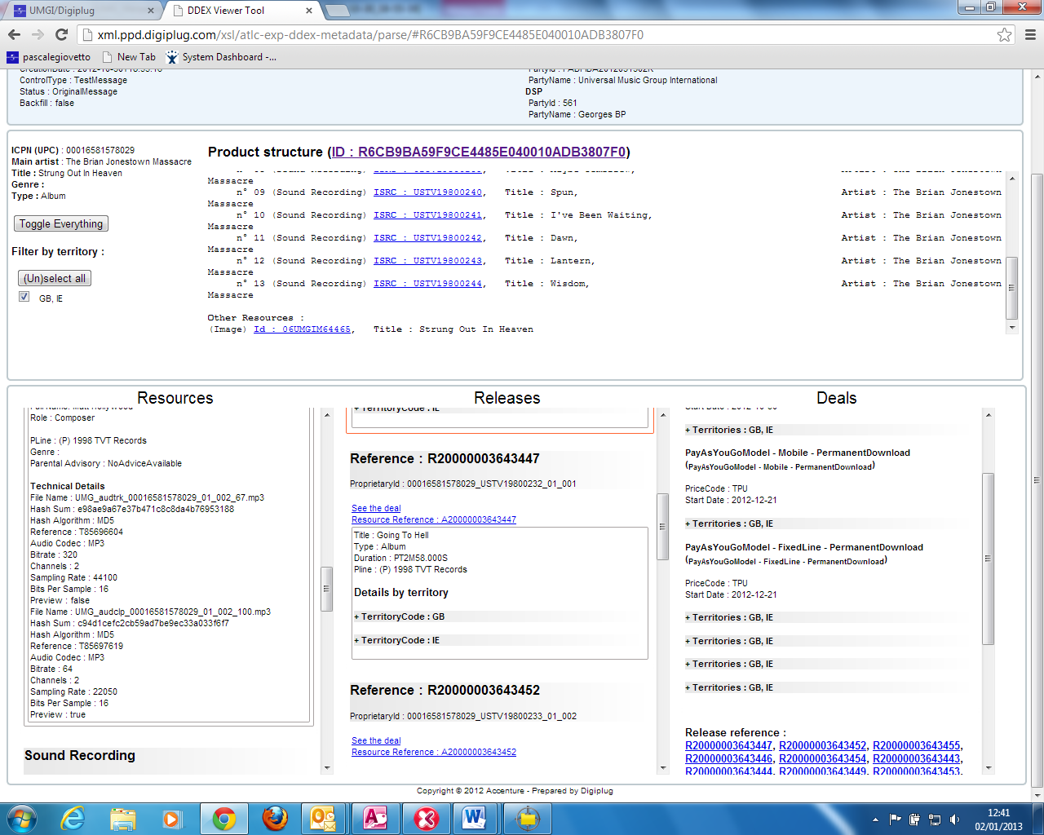

Annex 2: 00602527666235

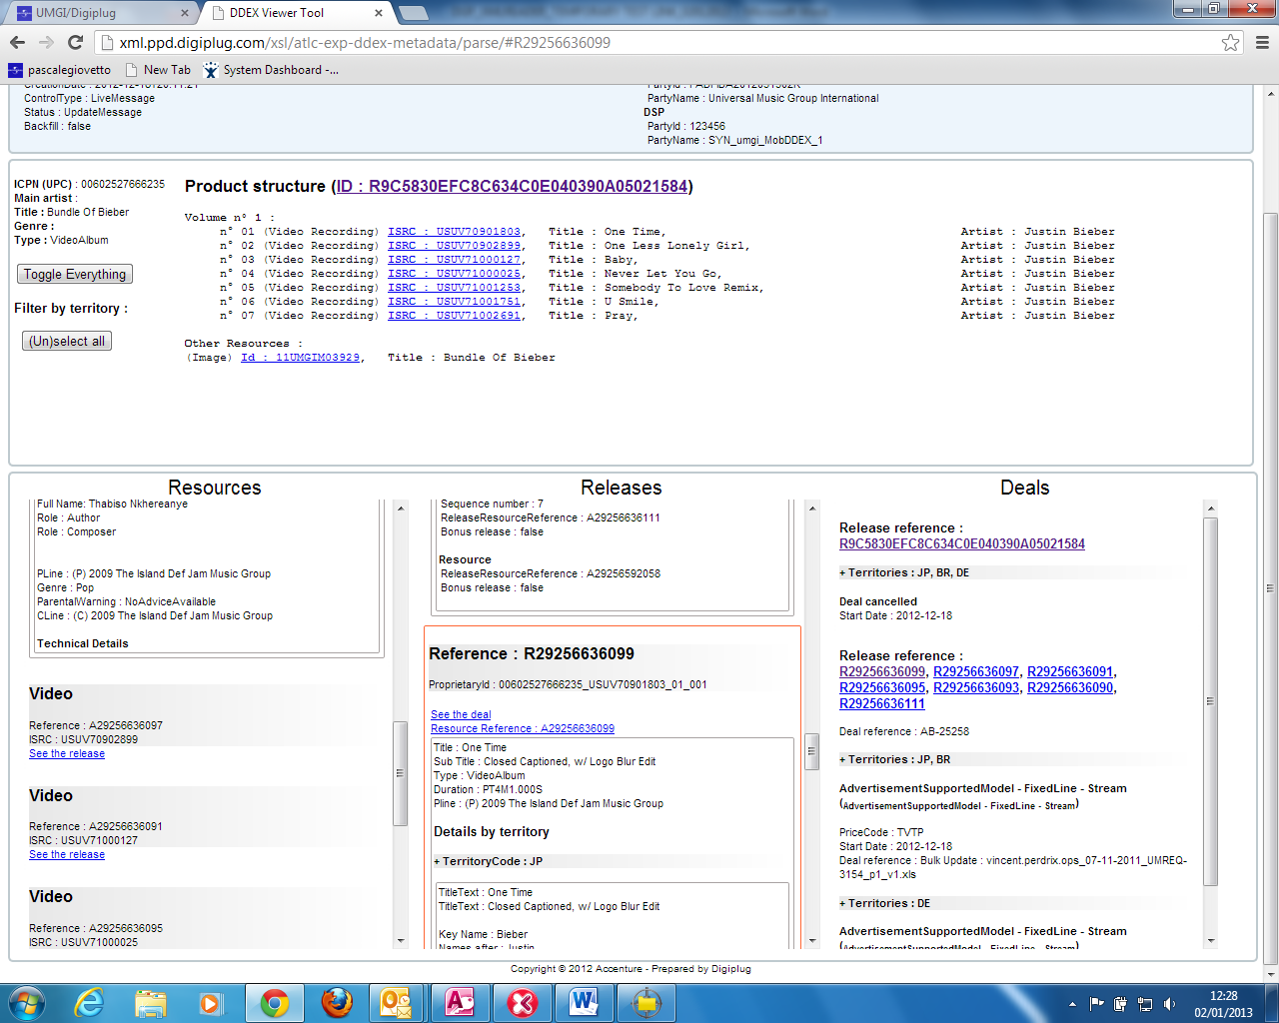

Annex 3: Same UPC as Annex 1

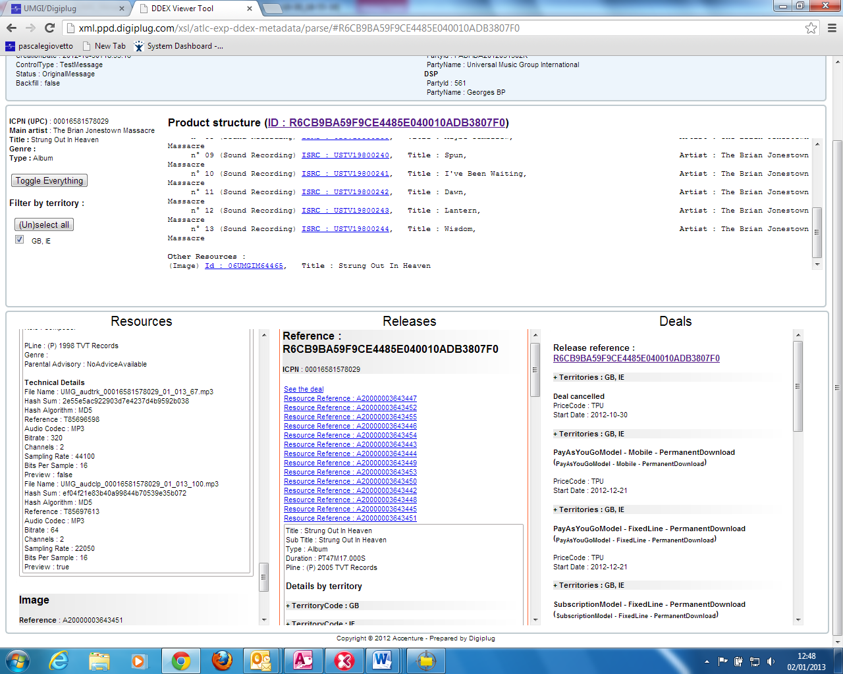

Annex 4: 00028943426022

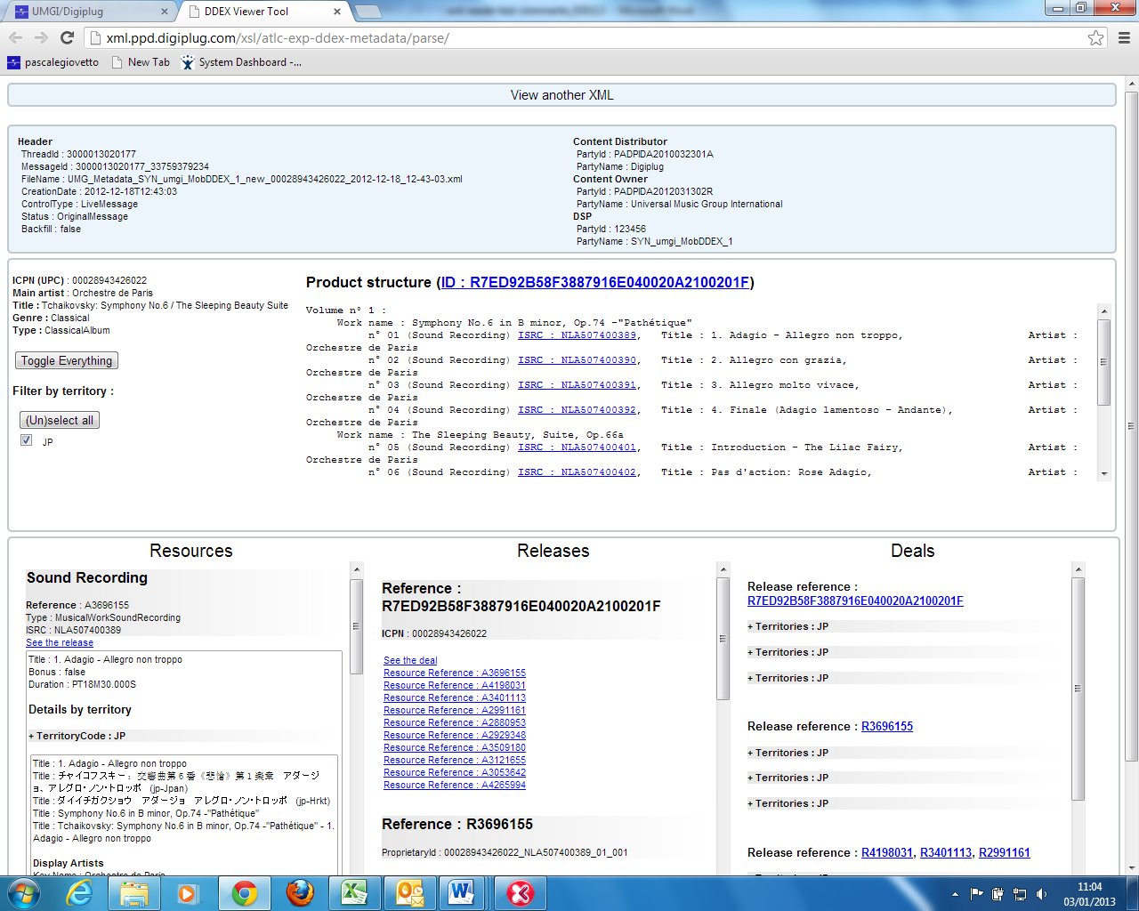

Annex 5: Same UPC as Annex 2

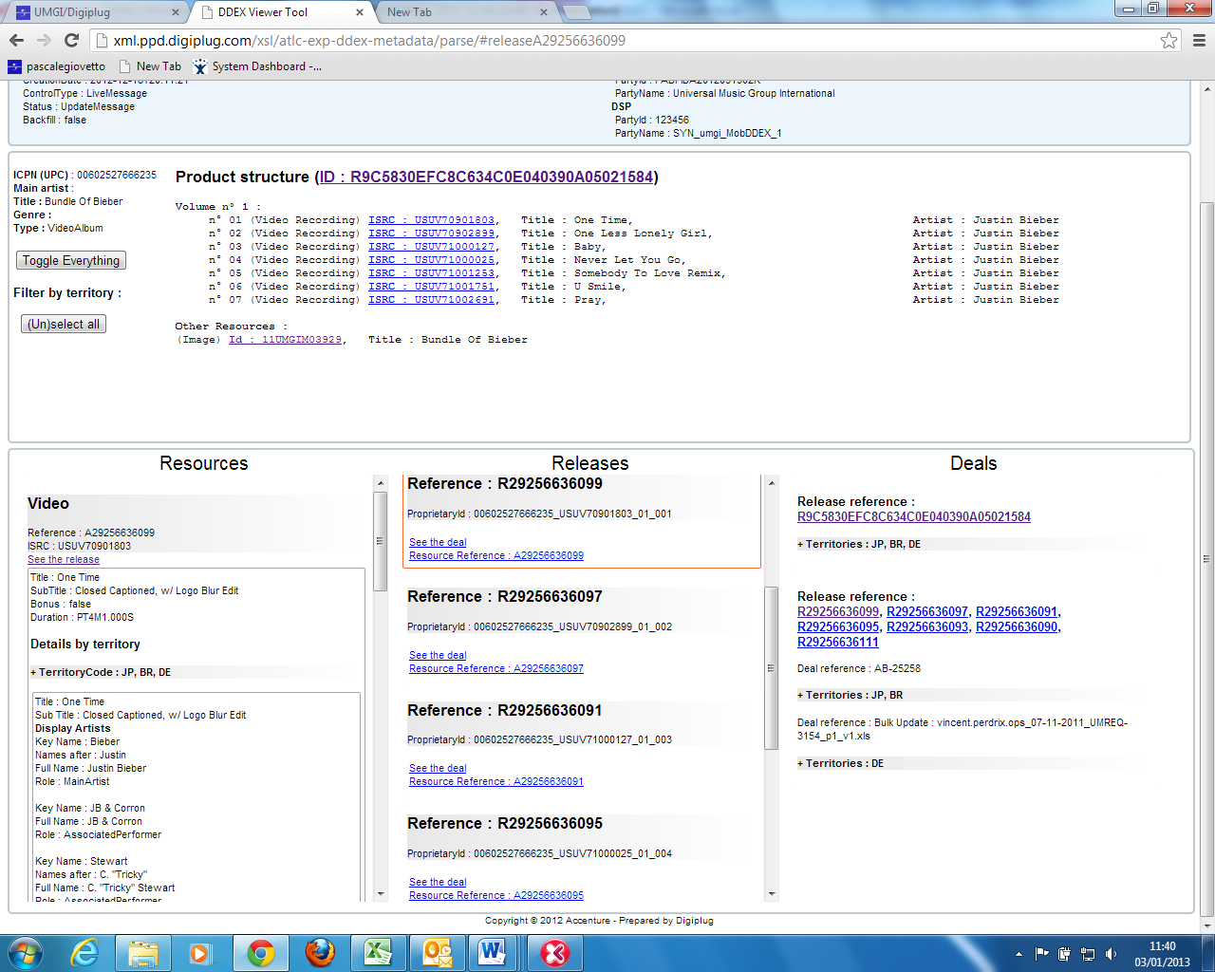

Annex 6: DGP-L-718149

